Practical 9
Aim:To understand how to use MongoDB

About MangoDB:
MongoDB is an open-source document database and leading NoSQL database. MongoDB is written in C++..

use database_name:
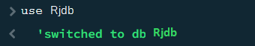

createCollection()
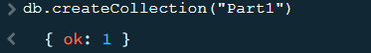

insertOne():
Syntax: db.collection_name.insertOne({record})
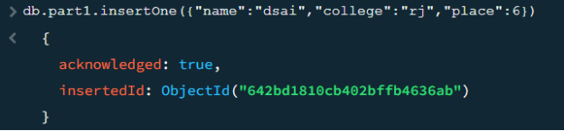

insertMany():
Syntax: db.collection_name.insertMany([{record},{record}])
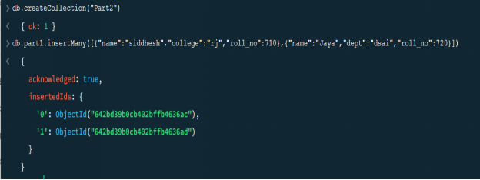

find():
Syntax: db.collection_name.find()
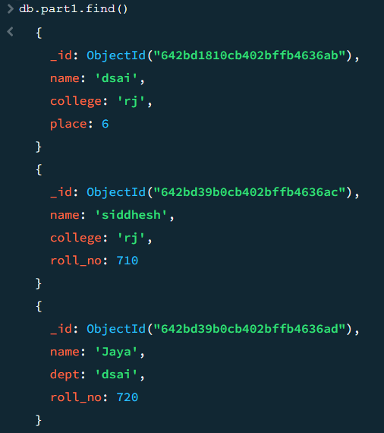

Selection in find():
You can select a single field in MongoDB using the following
syntax: db.yourCollectionName.find({"yourFieldName":yourValue});
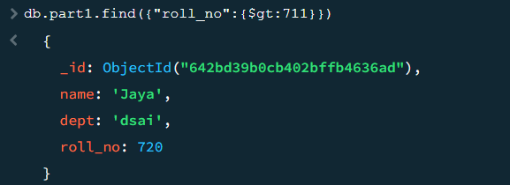

Projection in find():
Syntax: db.collection_name.find({},{"yourFieldName":1 or 0})
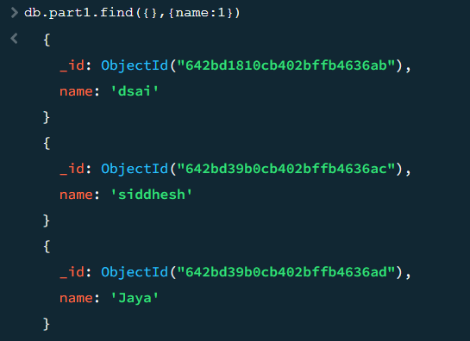

Comparsion operation in find():
Name | Description
$eq | Matches values that are equal to a specified value.
$gt | Matches values that are greater than a specified value.
$gte | Matches values that are greater than or equal to a specified value.
$in | Matches any of the values specified in an array.
$lt | Matches values that are less than a specified value.
$lte | Matches values that are less than or equal to a specified value.
$ne | Matches all values that are not equal to a specified value.
$nin | Matches none of the values specified in an array.

